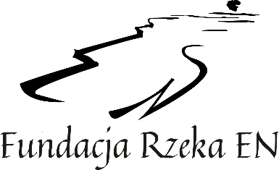
EN RIVER FOUNDATION
rzeka-en.pl

REPORT CARD
2ST SUMMER MUSIC MASTER CLASSES IN ZAMOSC
August 5-13, 2023.

- PARTICIPANT:
Surname:
Names:
Date and place of birth:

- ADDRESS, CONTACT INFORMATION:
City, zip code:
Street, number:
Phone:
E-mail:
University/School:

- PARTICIPATION IN THE COURSE:
Instrument:
Professor(s) at the Course:
Repertoire/Program to be prepared at the Course:

- ACCOMMODATION (fee upon arrival in Zamosc):
Participant's accommodation:  (underline legibly the appropriate or bold) | YES  (Inter-school Bursa No. 2 ) | NO  (arranges his own accommodation)
Accommodation  For parent or guardian: | YES | NO
Accommodation  on days (if applicable): | From: | To:
shared room with a friend: (name)

I hereby register my participation in the 2nd Summer Music Master Classes in Zamosc,
August 5-13, 2022:
Locality: Date: Signature:

